Report

**Section A; Directory structure**

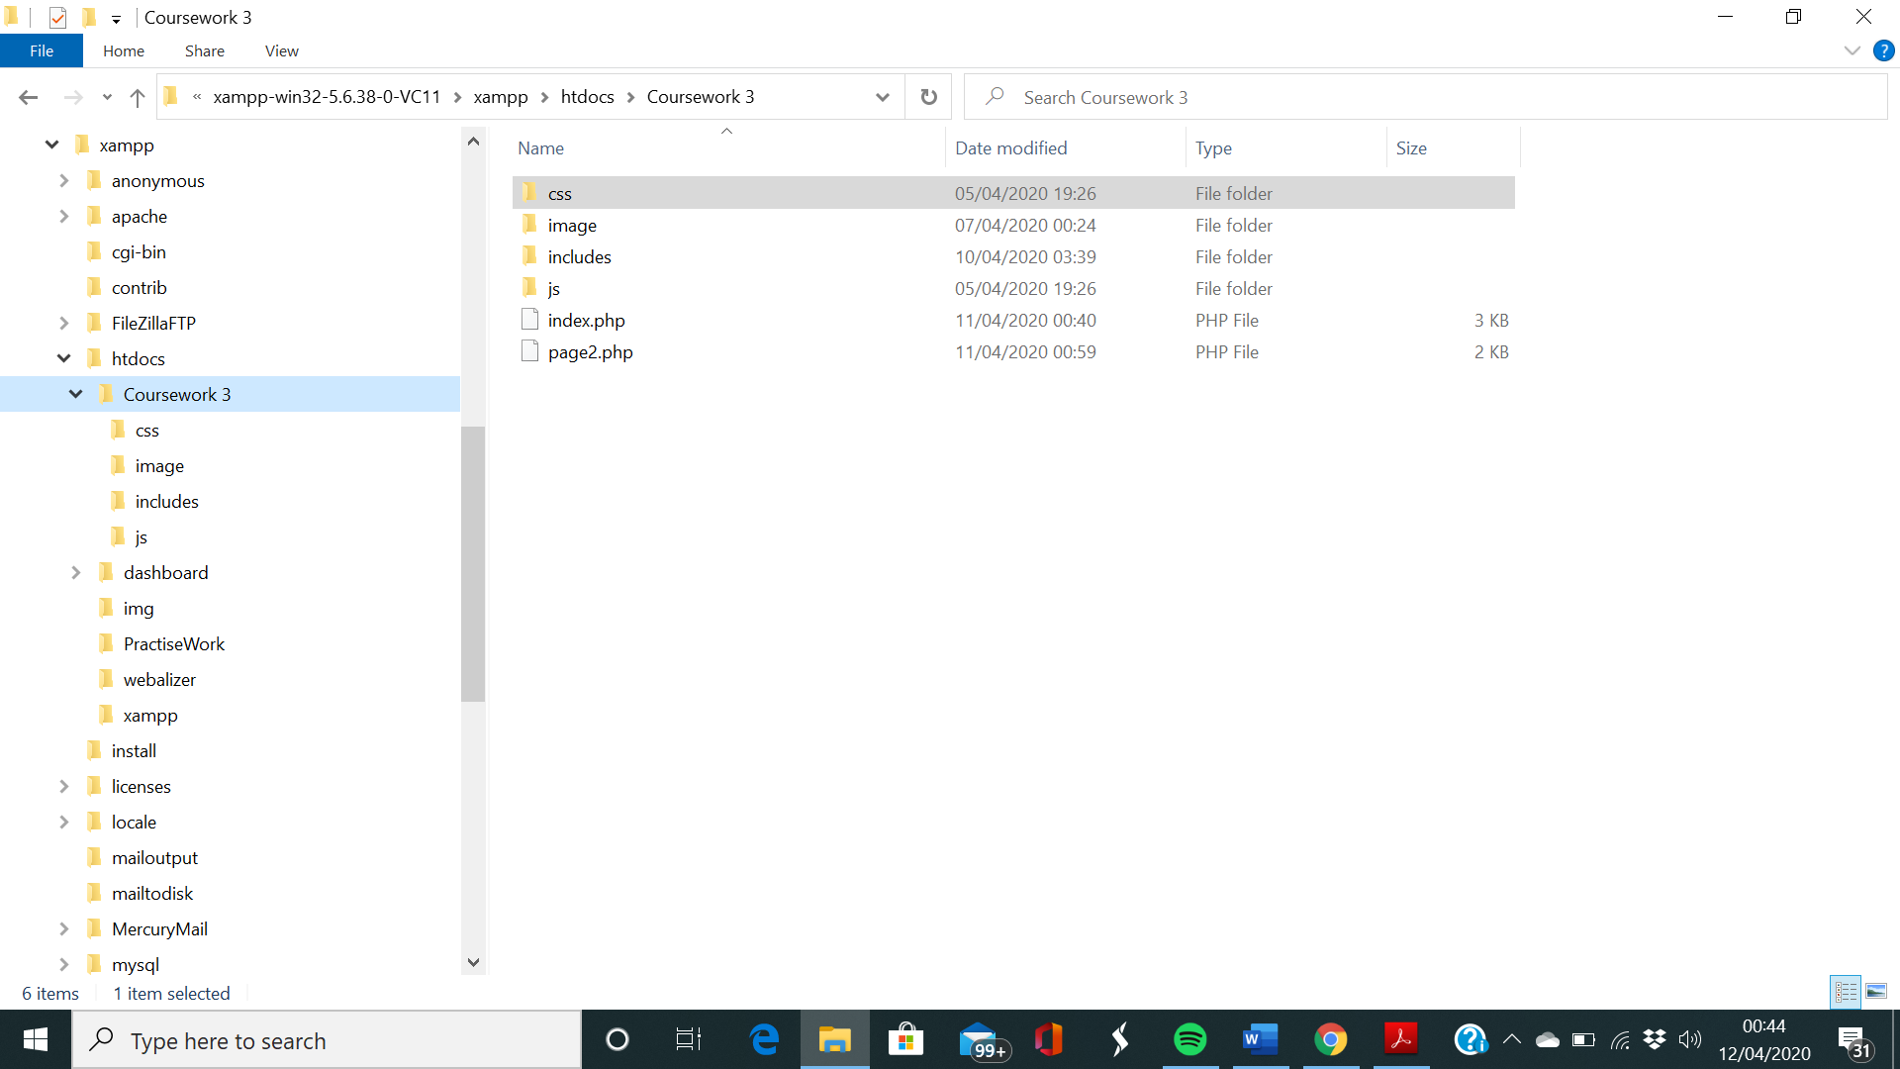

The above screenshot shows the outline of the overall directory structure of my project. As you can see above clearly, this folder called ‘Coursework 3’ is located within ‘htdocs’ which is within ‘xampp’. This directory has four further sub-directories which I will go into further on. There are two php files in ‘Coursework 3’ which contain php/html code for the webpages.

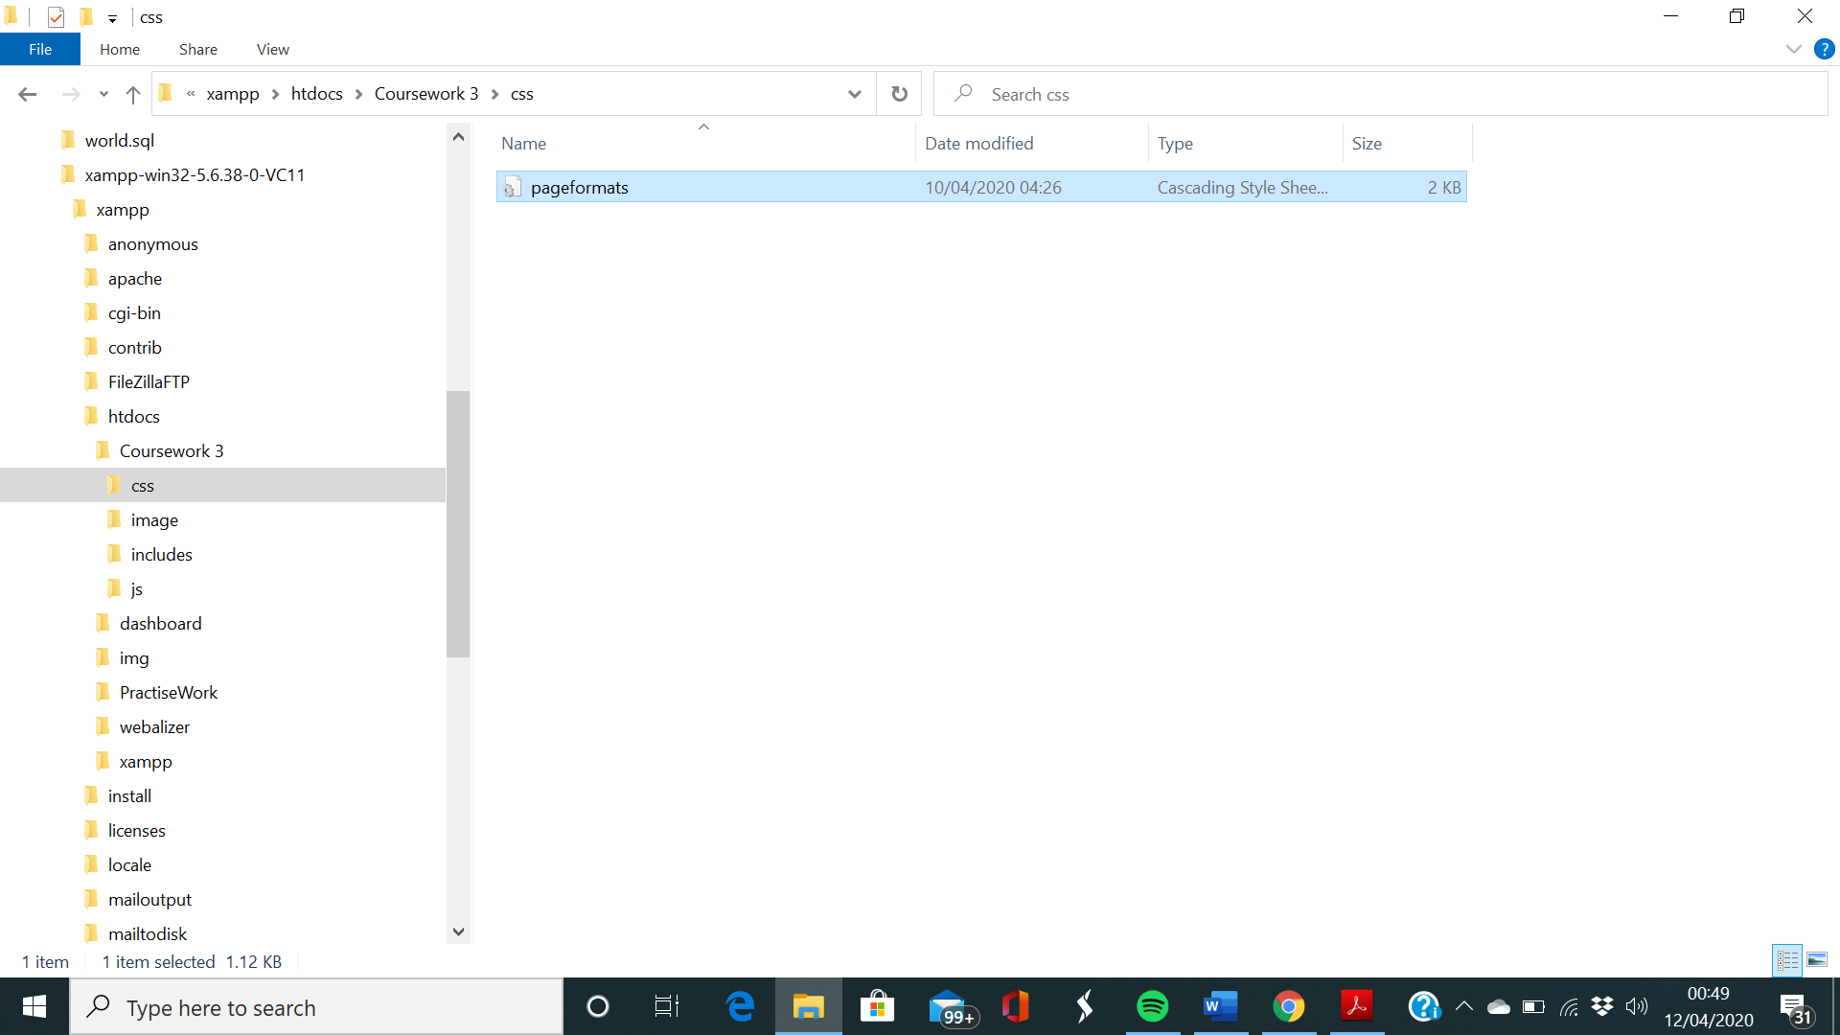

The above screenshot displays the contents of the directory ‘css’ which is a sub-directory of ‘Coursework 3’ and contains the Cascading Style Sheets for the html/php files.

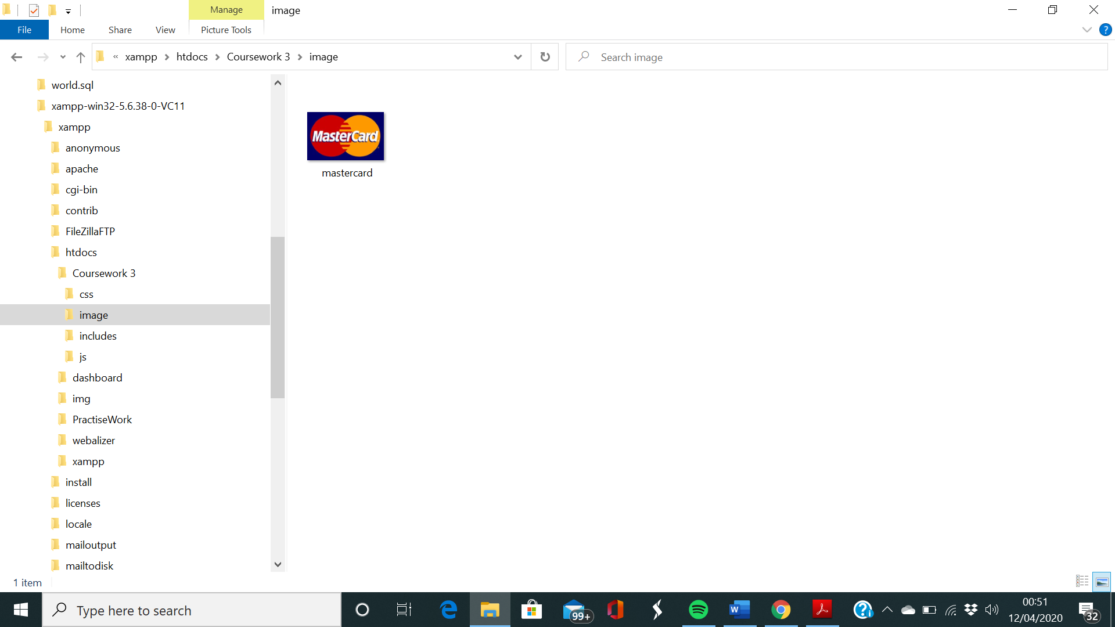

The above screenshot displays the contents of the directory ‘image’ which is a sub-directory of ‘Coursework 3’ and contains any image files to be used in the webpage.

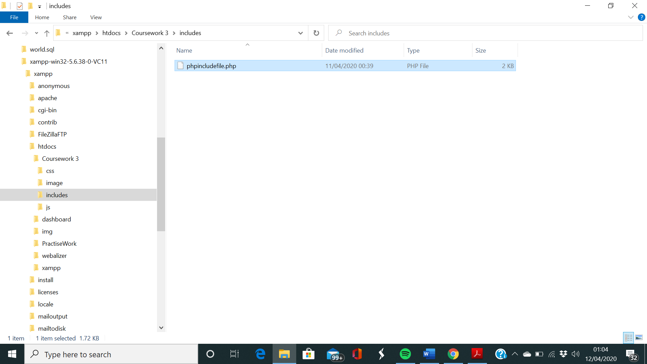

The following screenshot shows a php file within ‘include’. The php file, as the name suggests has php code to be included in ‘page2.php’

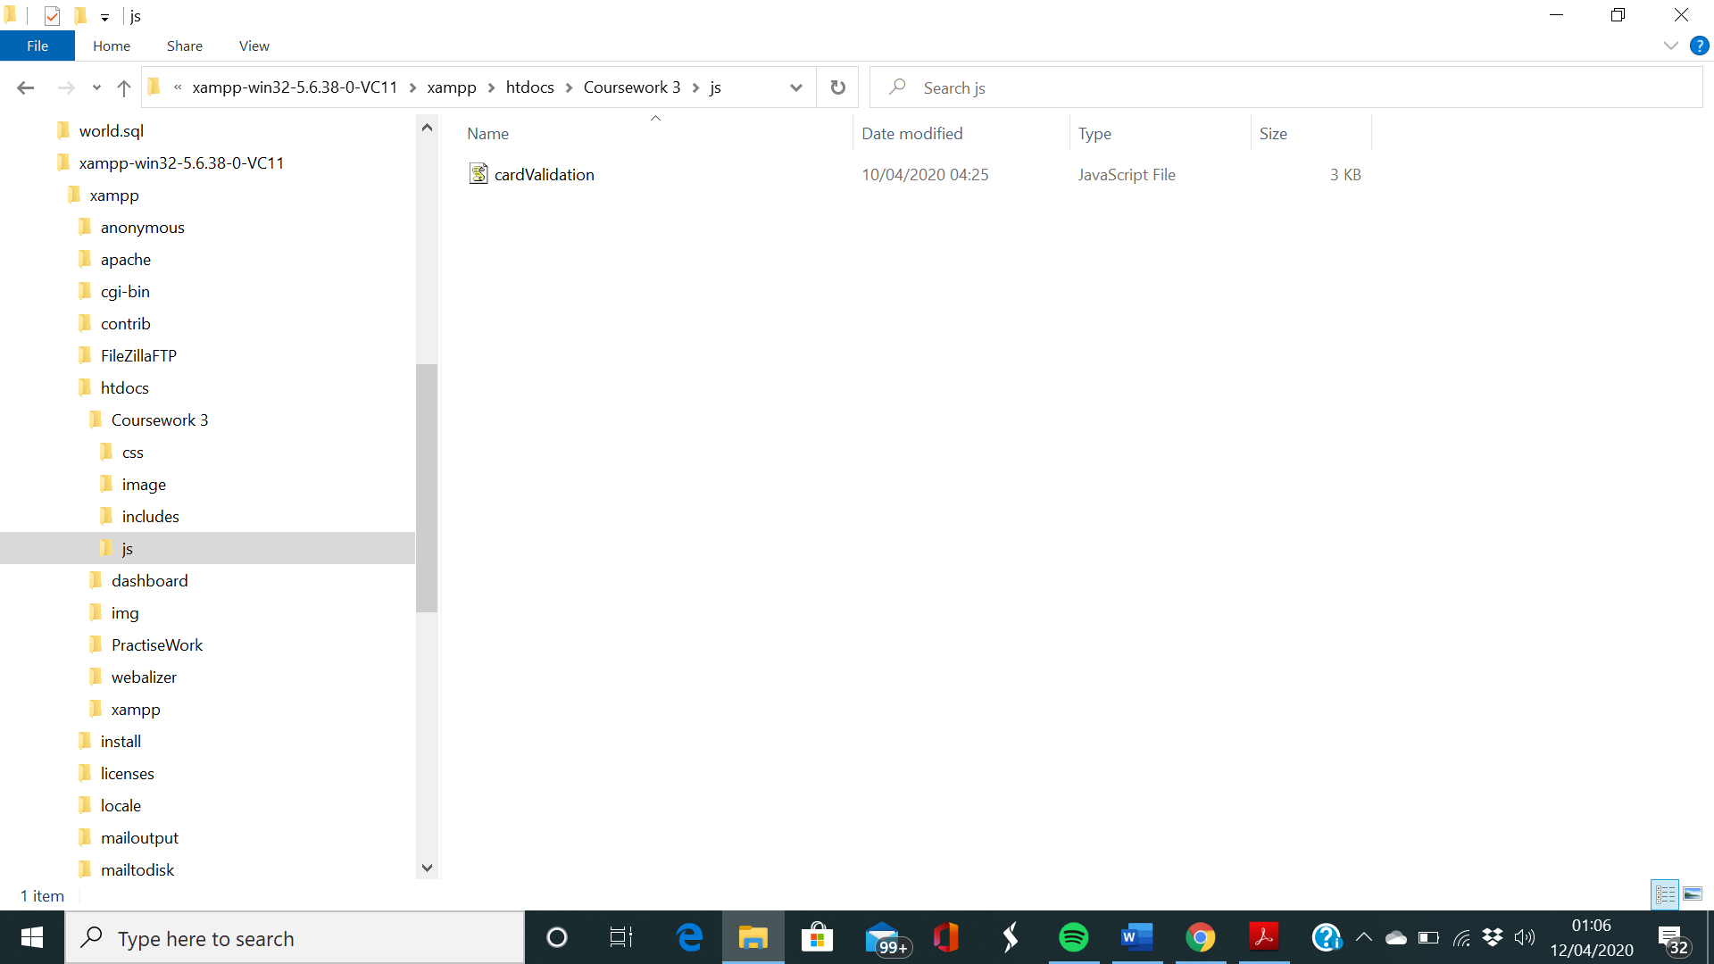

Finally, we have the ‘js’ sub-directory which contains a javascript file which contains code to verify form data within the ‘index.php’ file.

**Section B: Front webpage overview**

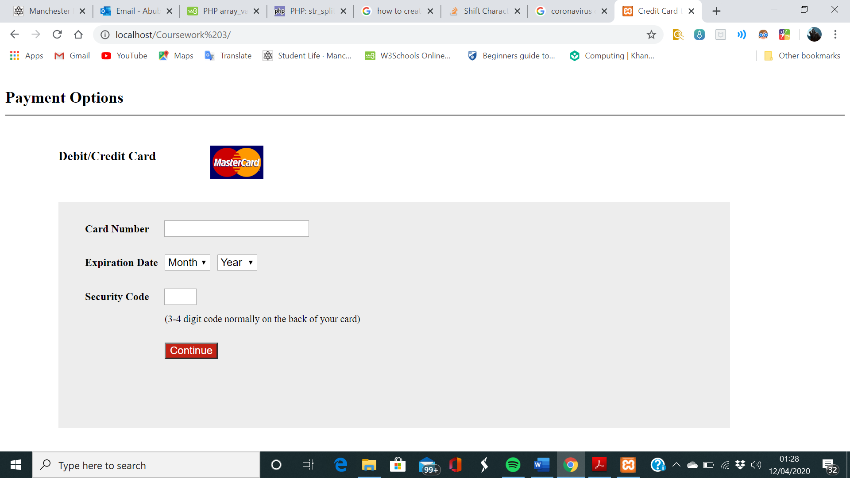

The following screenshot above features the index page of my custom-built credit card transaction website. It has a credit card verification system provided by the javascript code.

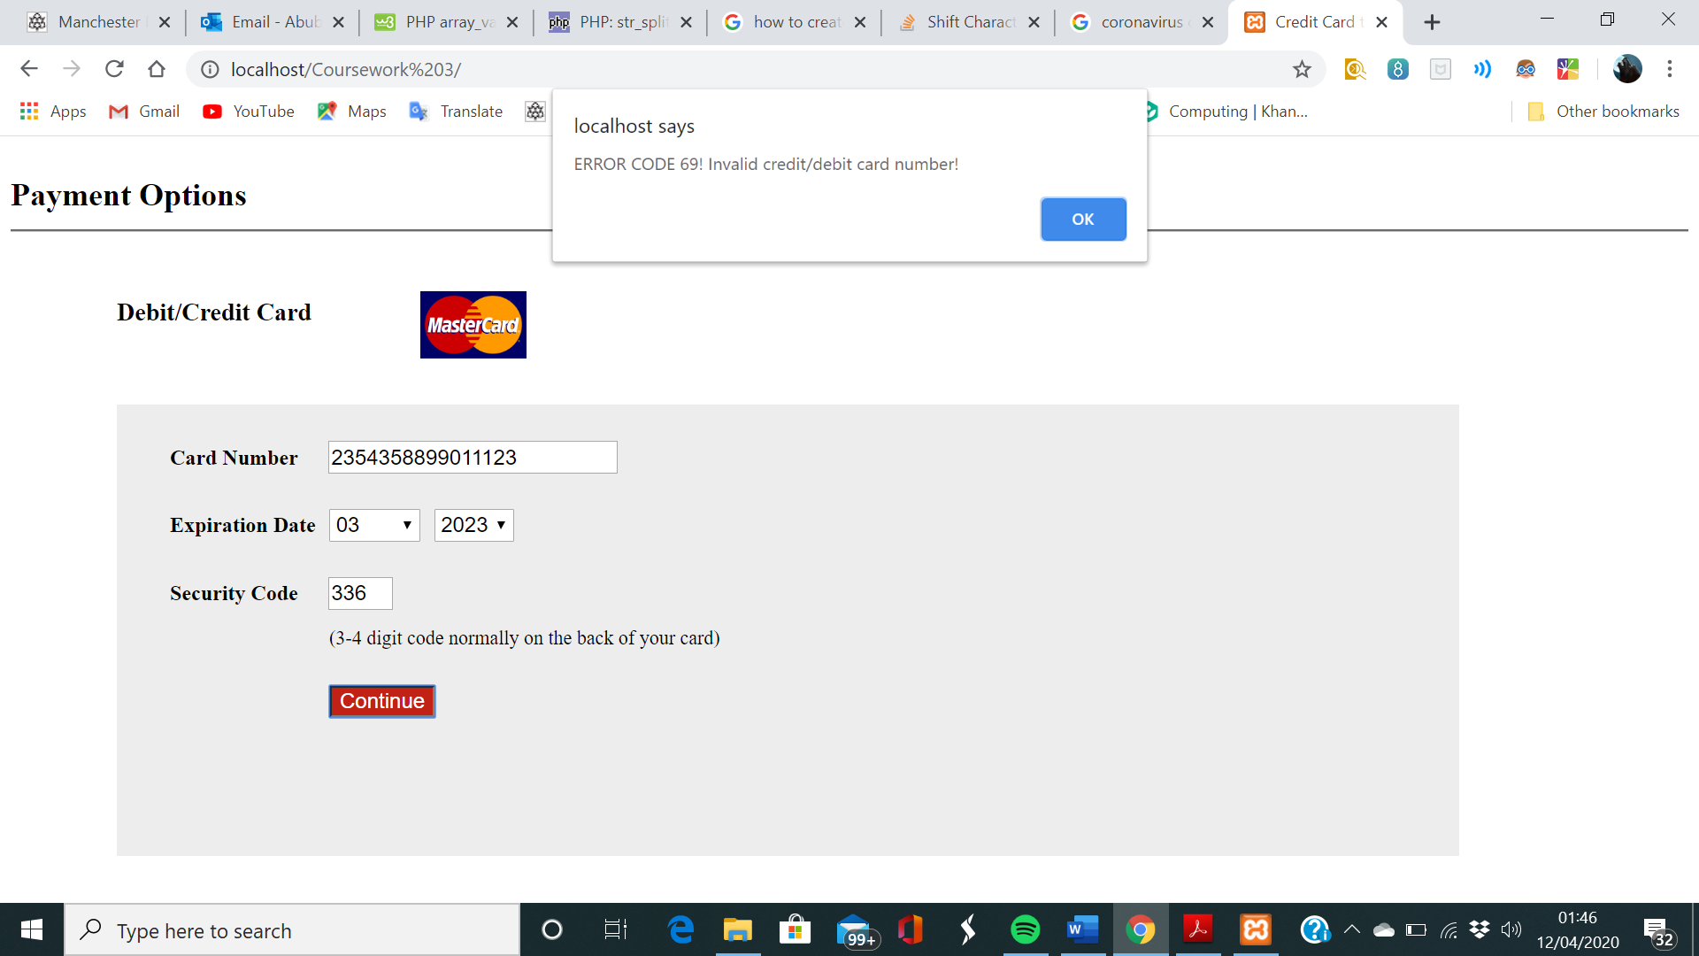

The following screenshot above represents an example of a failed attempt to store user’s credit card details. This is because as the alert box suggests, the card number is of an unidentified format. In fact, this 16-digit number was randomly typed in by me as a test. Once the user clicks ‘ok’ on the alert box the user is stuck on the same page until a valid card number is typed in.

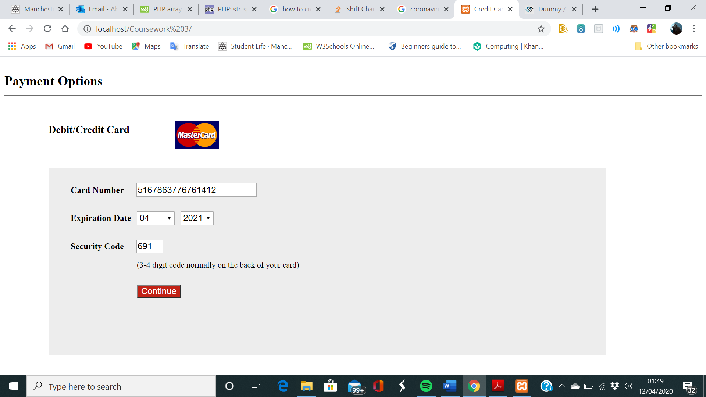

The above screenshot features a credit card number generated by a dummy card number generator (<https://saijogeorge.com/dummy-credit-card-generator/>) which is supposed to be of an acceptable format, in this case Mastercard.

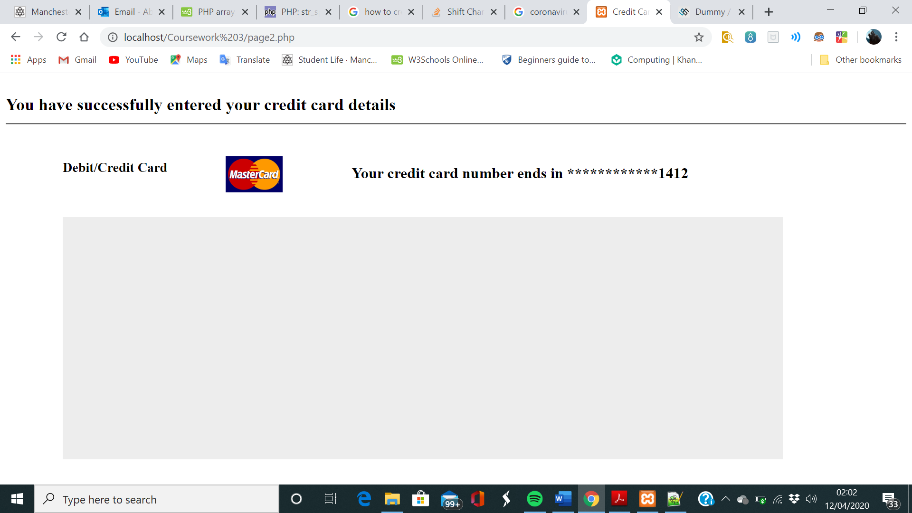

Finally, we have a representation of the valid card number making it through to the next page and being stored on the database after the javascript verification is successful.

**Section C: Database**

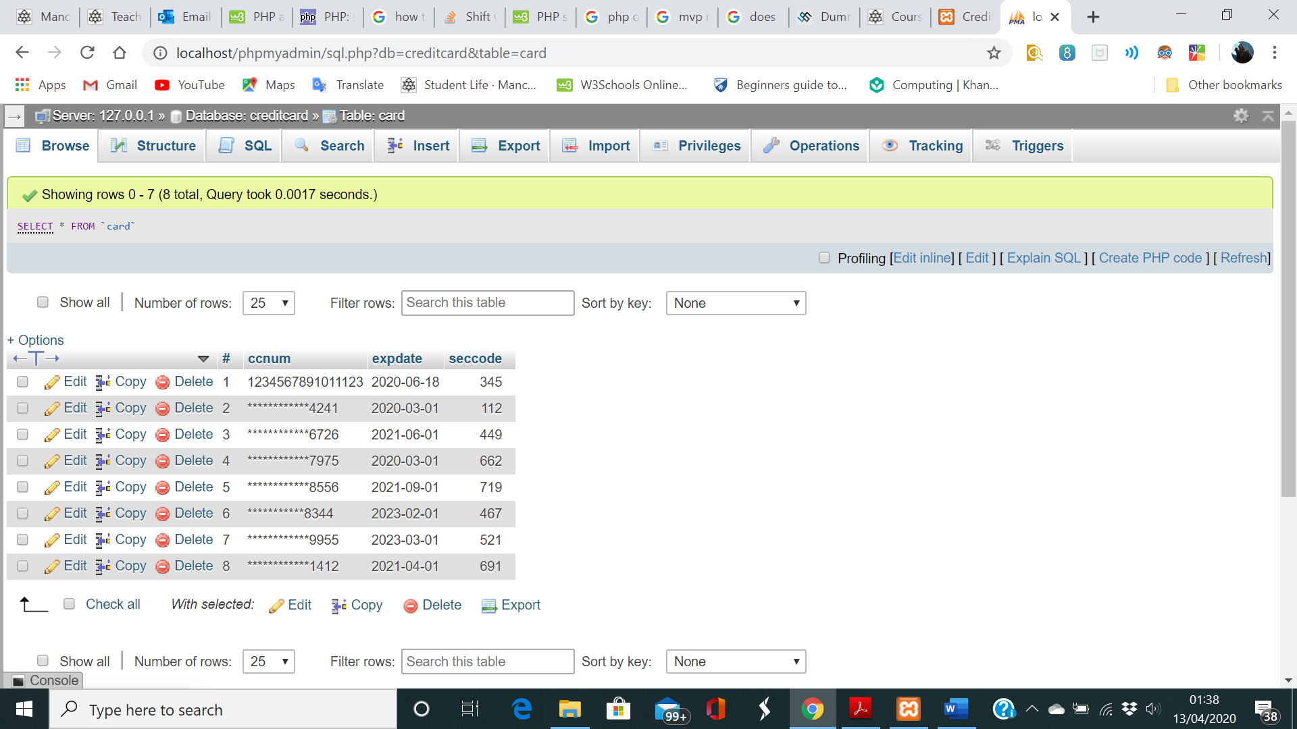

This screenshot demonstrates the credit card database table in action. If you read the directory information above it shows you that this database table is called ‘card’ which is located within the database called ‘creditcard’. As you can see the credit card information which I just recently entered (as shown in section b of this report) is stored in row 8 with a ‘#’ value of 8. All the card number digits are stored as asterisk form except last 4 digits as per the requirement of this coursework. Note that the first-row card number is the original row created with SQL code provided, hence it is not in asterisk form.

**Section D: Code appendix**

All PHP Code

*index.html:*

<!DOCTYPE html>

<html lang="en">

<head>

<meta charset="utf-8">

<title>Credit Card transaction scheme</title>

<link rel='stylesheet' href='css/pageformats.css' type='text/css' />

<script src="js/cardValidation.js"></script>

</head>

<body>

<header>

<h2>

Payment Options

</h2>

</header>

<div id="credit">

<h3 id="credith3" class="change">

Debit/Credit Card

</h3>

<img class="change" src="image/mastercard.jpg" alt="Mastercard Logo" width="80px" />

</div>

<div class="mail">

<form name="form1" action="page2.php" method="post" required onsubmit="return theBigPic(document.form1.Cardno,document.form1.month,document.form1.Year)">

<ul>

<li><label for="Cardno">Card Number</label><input type='text' name='Cardno' maxlength="19" id="input1"/></li>

<li>&nbsp;</li>

<li>

<label for="month">Expiration Date</label>

<select name="month" value="Month" required>

<option selected disabled>Month</option>/*Selected ensures it as pre-selected on loadup(title) however

since it is disabled it is not actually a real selectable value*/

<option value="01">01</option>

<option value="02">02</option>

<option value="03">03</option>

<option value="04">04</option>

<option value="05">05</option>

<option value="06">06</option>

<option value="07">07</option>

<option value="08">08</option>

<option value="09">09</option>

<option value="10">10</option>

<option value="11">11</option>

<option value="12">12</option>

</select>

<select name="Year" value="Year" required>

<option selected disabled>Year</option>

<option value="2020">2020</option>

<option value="2021">2021</option>

<option value="2022">2022</option>

<option value="2023">2023</option>

<option value="2024">2024</option>

<option value="2025">2025</option>

<option value="2026">2026</option>

<option value="2027">2027</option>

<option value="2028">2028</option>

<option value="2029">2029</option>

<option value="2030">2030</option>

</select>

</li>

<li>&nbsp;</li>

<li><label for="seccode">Security Code</label><input type="text" name="seccode" maxlength="4" id="input2" required></input></li>

<li id="liRandom">&nbsp;</li>

<li id="message">(3-4 digit code normally on the back of your card)</li>

<li>&nbsp;</li>

<li ><input id="submitbutton" type="submit" name="submit" value="Continue" onclick="cardNumberValidator(document.form1.Cardno)"/></li>

</ul>

</form>

</div>

</body>

</html>

*page2.html:*

<!DOCTYPE html>

<html lang="en">

<head>

<meta charset="utf-8">

<title>Credit Card transaction update</title>

<link rel='stylesheet' href='css/pageformats.css' type='text/css' />

</head>

<body>

<header>

<h2>

You have successfully entered your credit card details

</h2>

</header>

<div id="credit">

<h3 id="credith3" class="change">

Debit/Credit Card

</h3>

<?php

$cardno = $_POST["Cardno"];

$month = $_POST["month"];

$year = $_POST["Year"];

$seccode = $_POST["seccode"];

$sqlDate = $year."-".$month."-01";//date in sql format,integrated from previous variables containg month and year

$cardNoLength = strlen($cardno);//returns the length of the card number

if($cardNoLength>4){

$startingDigits = substr($cardno,0,$cardNoLength-4);//retrieves dighits before last 4 digits of the card

$last4Digits = substr($cardno,$cardNoLength-4);//retrieves last 4 digits of the card number, given its length is greater than 4

}

else{

$last4Digits = $cardno;//otherwise returns the cardNo as it is

}

$ccAsterisk = str_repeat("*",$cardNoLength-4);//repeats asterisk for every digit in the card number except last 4 digits

$maskedCardNum = str_replace($startingDigits,$ccAsterisk,$cardno);//new variable which replaces the card number to (*) values except last 4

?>

<img class="change" src="image/mastercard.jpg" alt="Mastercard Logo" width="80px" />

<h3 id="updateMsg">Your credit card number ends in <?php echo $maskedCardNum ?></h3>

</div>

<div class="mail">

</div>

<div>

<?php

include 'includes/phpincludefile.php';

?>

</div>

</body>

</html>

*phpincludefile.php:*

<?php

$servername = "localhost";

$username = "root";

$password = "";

$database = "creditcard";

$databaseConn = new mysqli($servername,$username,$password,$database);//connection to database established

/*

if($databaseConn->connect_errno){//if an error exists with the connection

die("ERROR!Connection Unsuccessful!".$databaseConn->connect_error);

}

else {

echo "(DATABASE CONNECTION SUCCESSFUL)"."<br>";

}

*/

//------------------------------------------------------------------------------------------------------------------------------------------------------

$sqlQuery = "SELECT COUNT(ccnum) FROM `card`";//sql statement which returns an integer value for the numbers of rows

$result = $databaseConn->query($sqlQuery) or die($databaseConn->error);

while($row = $result->fetch_assoc()){

$rowResult = $row["COUNT(ccnum)"];//value stored in new variable

}

$PK_ID = $rowResult+1;//primary key id (#) basedupon number of rows in database + 1

//----------------------------------------------------------------------------------------------------------------------------------------------------

$mainSqlQuery = "INSERT INTO`card`(`#`,`ccnum`,`expdate`,`seccode`)Values($PK_ID,'$maskedCardNum','$sqlDate',$seccode)";

$result = $databaseConn->query($mainSqlQuery) or die($databaseConn->error);//query applied to mySQL/if not then end the script and show error

/*

if($result){//if the sql query executes successfully

echo "(NEW RECORD CREATED SUCCESSFULLY)";

}

else {

echo "ERROR!".$databaseConn->error;

}

*/

//-----------------------------------------------------------------------------------------------------------------------------------------------------

$databaseConn->close();//close connection to the database

?>

JavaScript code

*cardValidation.js:*

function theBigPic(var1,var2,var3)/*3 placeholder values to be passed on to further functions inside */{

var inputtxt = var1;

var formelement1 = var2;

var formelement2 = var3;

function cardNumberValidator(inputtxt)//function which compares user input cc number to actual credit card number formats

{

var masterCard = /^(?:5[1-5][0-9]{14})$/;//variable containing the format for a mastercard number

var visa = /^(?:4[0-9]{12}(?:[0-9]{3})?)$/;//variable containing the format for a visa number

var americanExpress = /^(?:3[47][0-9]{13})$/;//variable containing the format for an american Express number

var dinersClub = /^(?:3(?:0[0-5]|[68][0-9])[0-9]{11})$/;//variable containing the format for dinersclub number

var discover = /^(?:6(?:011|5[0-9][0-9])[0-9]{12})$/;//variable containing the format for a discover number

var jcb = /^(?:(?:2131|1800|35\d{3})\d{11})$/;//variable containing the format for a jcb number

if(inputtxt.value.match(masterCard) || inputtxt.value.match(visa) || inputtxt.value.match(americanExpress)//if the user input cc number matches

|| inputtxt.value.match(dinersClub) || inputtxt.value.match(discover) || inputtxt.value.match(jcb))//any of these variable formats

{

return true;

}

else

{

alert("ERROR CODE 69! Invalid credit/debit card number!");

return false;

}

}

function formValidation(formelement1,formelement2){//function to validate whether month and year select fields have been chosen

if(formelement1.value == "Month" || formelement2.value == "Year"){//if the select fields still have original pre-selected values

alert("ERROR! You haven't filled out all of the fields!");

return false;//then return false i.e the select fields have not been selected by user

}

}

formValidation(formelement1,formelement2);//call made to functions

cardNumberValidator(inputtxt);

if (formValidation(formelement1,formelement2) == false || cardNumberValidator(inputtxt) == false){

return false;//if any of the called functions return false, then return false as a whole for the entire function

}

}

CSS Code

*pageformats.css:*

header {

height:50px;

border-width:2px;

border-bottom-style: groove;

border-bottom-color:silver;

}

header h2 {

position:relative;

bottom:-10px;

}

#credit {

height:80px;

width:60%;

margin-top:50px;

margin-left:80px;

}

img{

float:right;

position:relative;

bottom:45px;

right:450px;

}

#updateMsg{

float:right;

position:relative;

font-size:16pt;

bottom:55px;

left:200px;

}

.mail {

margin-left:80px;

padding-top: 10px;

padding-bottom: 10px;

height:320px;

width: 80%;

background : #ededed;

border: 1px soild silver;

}

li {list-style-type: none;

font-size: 16pt;

}

.mail h2 {

margin-left: 38px;

}

input {

font-size: 12pt;

margin-left:23px;

}

#input1{

width:24ch;

}

#input2 {

width:5ch;

}

input:focus, textarea:focus{

background-color: lightyellow;

}

label{

font-size:12pt;

font-weight:600;

}

select {

font-size:12pt;

margin-left:5px;

height:25px;

}

#submitbutton {

font-size: 12pt;

color:white;

background:#c22215;

border-color:grey;

margin-left:120px;

}

#liRandom {

height:13px;

}

#message {

font-size:11pt;

margin-left:120px;

}